1. Compute the volume of a cylindrical shell with an inner radius r1=5, an outer radius r2=6, and length=10.

**Results**

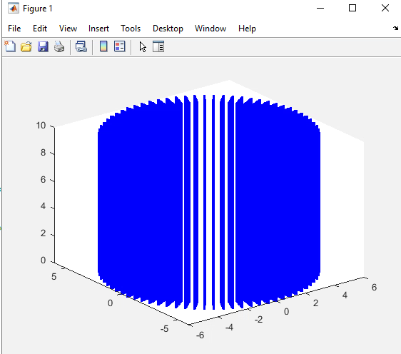



**Code**

Find attached with submission

1. Compute the area of a sphere of radius 10.

**Results**

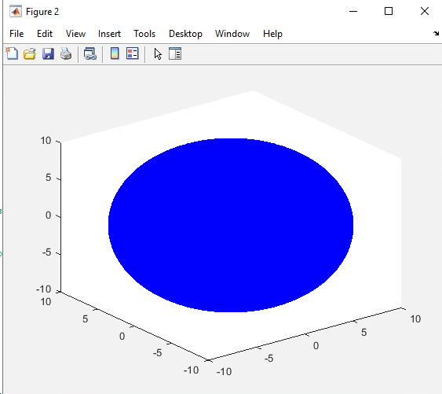



**Code**

Find attached with submission